Kickstarter project

Assignment # 1

BCS - Excel

Jose Luis Bracho

Kickstarter Project

The problem:

Over $2 billion has been raised using the massively successful crowdfunding service, Kickstarter, but not every project has found success. Of the more than 300,000 projects launched on Kickstarter, only a third have made it through the funding process with a positive outcome.

Getting funded on Kickstarter requires meeting or exceeding the project's initial goal, so many organizations spend months looking through past projects in an attempt to discover some trick for finding success. For this week's homework, you will organize and analyze a database of 4,000 past projects in order to uncover any hidden trends.

Requested:

1. Given the provided data, what are three conclusions we can draw about Kickstarter campaigns?

* In general, approximately 50% of projects have been successful. See Figure 1.
* Figure 1 shows that the highest percentage (>58%) of successful projects are in the categories of Film & Video, Music and Theater. While the worst projects (< 33% of success) are in the branch of journalism, food and publicity, being all the projects of the journalism sector cancelled. Based on that fact, the target must be in Music, Theater and Film & Video. Figure 2 is a complementary one that shows how the sub-categories of Music, Theater and Film & Video are the most successful.
* Figure 2 shows sub-categories that are 100% successful (classic music, documentary, electronic music, hardware, metal, nonfiction, pop, radio, podcasts, rock, shorts, tabletop games, television). Music projects are the most successful.
* Figure 4 shows that the number of current (Mar-2017) projects is very low 50, which represents 1.2% only. Figure 4 also shows that the project state has a relationship with the goal, that is the lower the goal, the higher the percentage of success number. On the other hand, the higher the goal, the higher the percentage of failed and canceled projects.

1. What are some limitations of this dataset?

Some column identifier does not indicate the units when it refers to a physical quantity, for example goal could be M$ (thousands of dollars) or MM$ (millions of dollars).

In the case of column Country, no everyone knows the abbreviation for each country, so in this case to put the complete name is desirable.

1. What are some other possible tables and/or graphs that we could create?

A line plot of launching date vs count of states would show how number of projects increased dramatically from year 2013 (274 projects) through 2015 (1225 projects) when started to decline until year 2017 (157 projects). Before year 2014, the projects rate of success was in average 74%, while after that was 46%.

Figures:

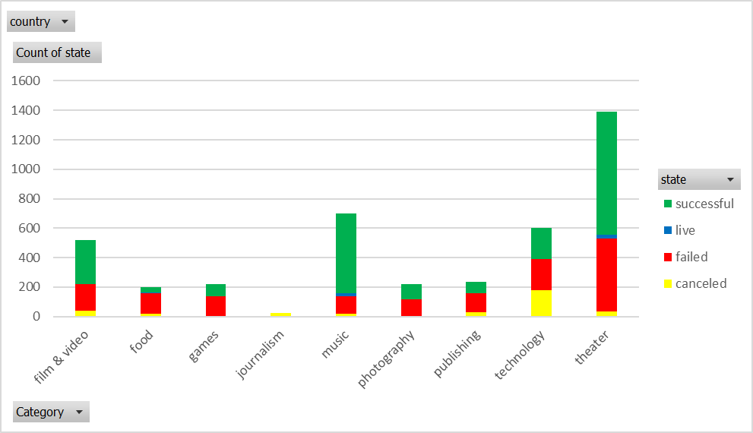

Figure 1. States by categories.

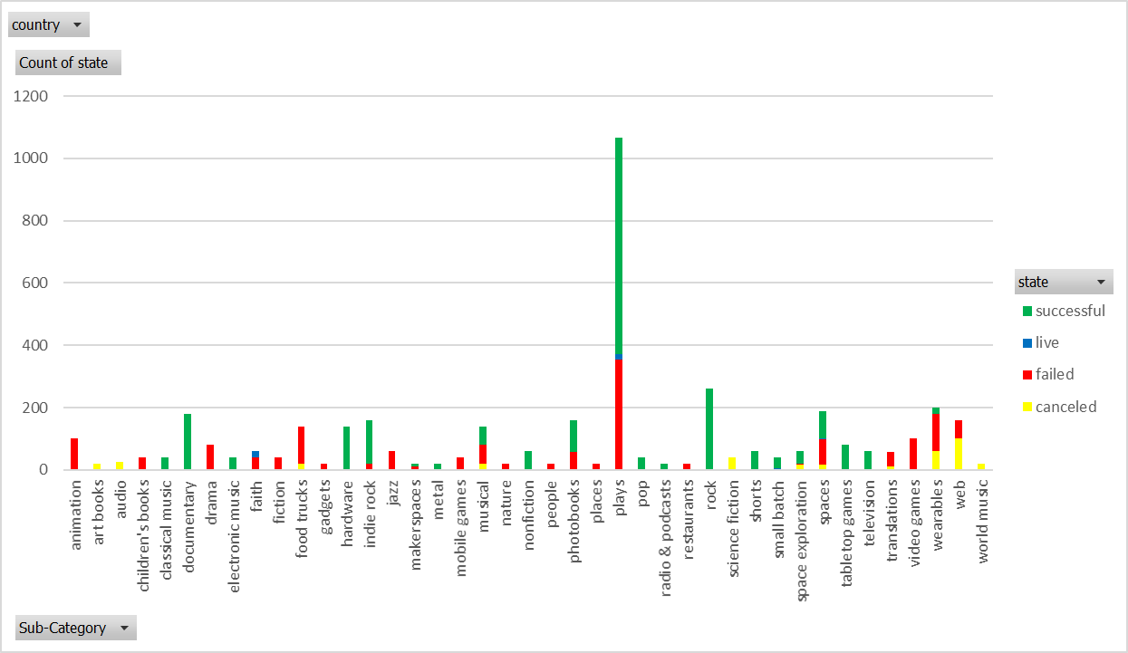

Figure 2. States by sub-categories.

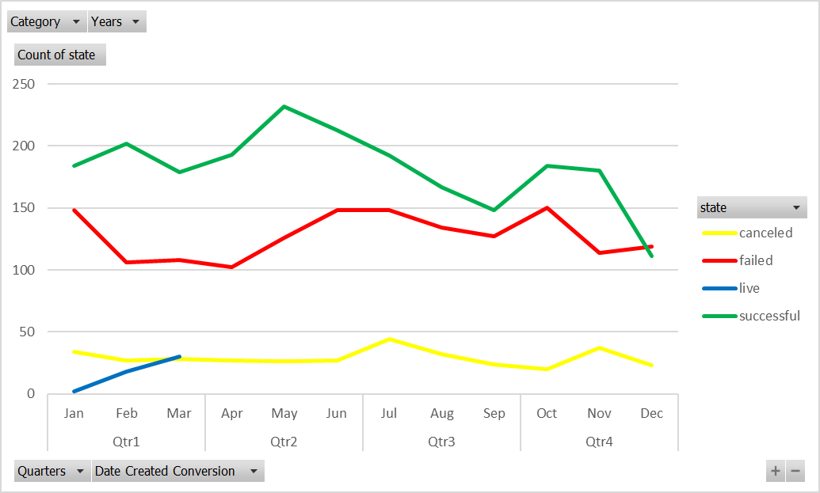

Figure 3. States correlated with specific month of the year.

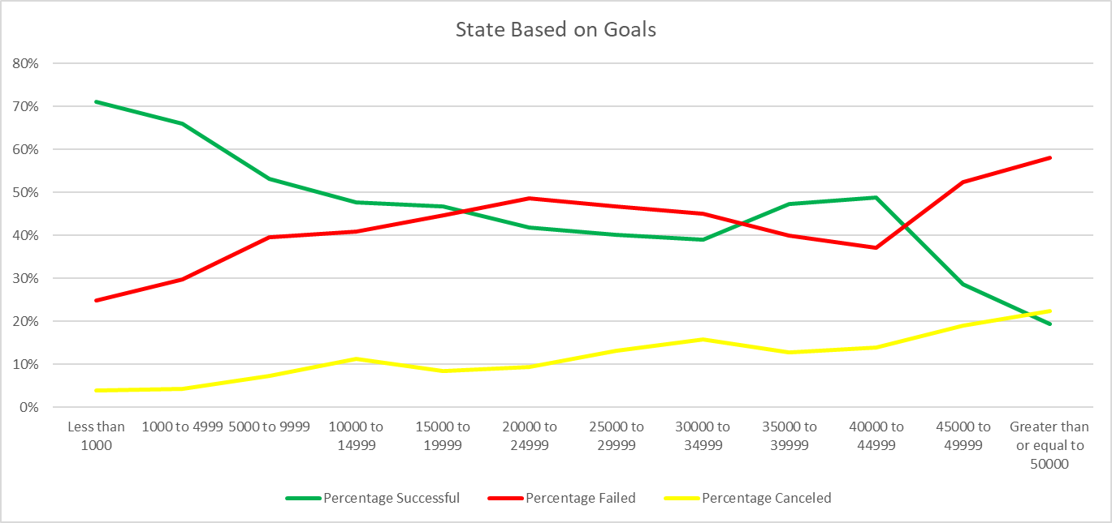

Figure 4. Percentage of states based on goals.